BEAUTY HUB COSMETIC MANAGEMENT SYSTEM

Enterprise Application Development (EAD)

Project Report
Submitted By:
Jenisa Budha Chhetri
Program:
Bachelor of Computer Science and Information Technology (BCSIT)
College:
KFA Business School
Technology Used:
Python, Django, HTML, CSS, Oracle Database
Academic Year:
2026

TABLE OF CONTENTS
- Introduction
- Background of the Project
- Problem Statement
- Objectives of the Project
- Scope of the Project
- Significance of the Project
- Technologies Used
- System Requirements
- System Features
- System Design
- Database Design
- System Implementation
- Oracle Database Connectivity
- Testing
- Results and Discussion
- Advantages of the System
- Limitations
- Future Enhancements
- Conclusion
- Reference

1. INTRODUCTION
Beauty Hub Cosmetic Management System is a web-based enterprise application developed to manage the daily activities of a cosmetic shop.
Cosmetic shops need to maintain information about products, prices, stock, customers and sales. Managing these activities manually using notebooks or spreadsheets can be time-consuming and may result in errors. Therefore, this project provides a computerized system for managing cosmetic products and sales efficiently.
The system is developed using Python and Django as the backend framework, HTML and CSS for the user interface, and Oracle Database for storing application data.
The main purpose of the Beauty Hub Cosmetic Management System is to provide an easy-to-use platform where a shop administrator can manage products, customers, inventory and sales from a centralized system.

2. BACKGROUND OF THE PROJECT
Cosmetic products include skincare, makeup, hair-care and other beauty-related products. A cosmetic shop may have a large number of products with different prices and quantities.
In a traditional manual system, the shopkeeper needs to record product information, update stock after every sale and calculate sales manually. This can lead to problems such as incorrect stock records, calculation errors and difficulty finding previous sales.
The Beauty Hub Cosmetic Management System was developed to solve these problems by automating major shop-management activities.
The system provides product management, customer management, sales recording, stock management, search and filtering, sales history and dashboard functionality.

3. PROBLEM STATEMENT
Traditional cosmetic shop management methods have several limitations.
The major problems are:
- Manual recording of products and sales.
- Difficulty maintaining accurate stock information.
- Manual calculation of sales amounts.
- Difficulty searching for products.
- Difficulty maintaining customer information.
- Lack of centralized sales records.
- Increased possibility of human errors.
- Difficulty monitoring low-stock products.
- Difficulty generating basic business information.
Therefore, a computerized cosmetic management system is required to make the management process faster, easier and more accurate.

4. OBJECTIVES OF THE PROJECT

4.1 Main Objective
The main objective of the project is to develop a web-based Cosmetic Management System that can efficiently manage cosmetic products, customers, inventory and sales.

4.2 Specific Objectives
The specific objectives are:
- To create a computerized cosmetic product management system.
- To add, update and delete product information.
- To maintain product prices and stock quantities.
- To provide product searching and category filtering.
- To manage customer information.
- To record product sales.
- To automatically calculate the total sale price.
- To automatically reduce product stock after a sale.
- To prevent users from selling products when sufficient stock is unavailable.
- To maintain sales history.
- To provide a dashboard showing important business information.
- To use Oracle Database for enterprise-level data storage.

5. SCOPE OF THE PROJECT
The Beauty Hub Cosmetic Management System focuses on the basic management requirements of a cosmetic shop.
The scope includes:

Product Management
- Add products.
- Edit products.
- Delete products.
- View products.
- Search products.
- Filter products by category.
- Monitor product quantity.

Customer Management
- Add customers.
- Store customer name.
- Store phone number.
- Store email.
- Store address.

Sales Management
- Select a product.
- Select a customer.
- Enter quantity.
- Record sales.
- Calculate total price automatically.
- Reduce stock automatically.
- Display sales history.

Dashboard
The dashboard provides information such as:
- Total products.
- Total stock.
- Total sales.
- Total revenue.

6. SIGNIFICANCE OF THE PROJECT
The Beauty Hub Cosmetic Management System can provide several benefits to a cosmetic business.
The system helps reduce manual work and improves the accuracy of product and sales records.
It allows the administrator to quickly search for products and monitor available stock. Sales are recorded electronically, making it easier to maintain historical records.
The system also demonstrates the practical use of enterprise application development concepts such as database management, CRUD operations, business logic, validation and web-based application development.

7. TECHNOLOGIES USED

7.1 Python
Python is used as the primary programming language for developing the backend logic of the system.

7.2 Django
Django is a Python-based web framework used to develop the web application. It provides URL routing, models, views, templates, administration and database integration.

7.3 HTML
HTML is used to create the structure of the web pages.

7.4 CSS
CSS is used to design and style the user interface of the Beauty Hub application.

7.5 Oracle Database
Oracle Database is used as the database management system for storing product, customer and sales information.

7.6 Python Oracle Driver
The Python oracledb package is used to establish communication between Python/Django and Oracle Database.

8. SYSTEM REQUIREMENTS

8.1 Hardware Requirements
- Computer or laptop
- Minimum 4 GB RAM
- Minimum 10 GB available storage
- Keyboard
- Mouse

8.2 Software Requirements
- Windows Operating System
- Python 3.14
- Django
- Oracle Database XE
- Oracle Database driver (oracledb)
- Web browser
- Visual Studio Code or another code editor

9. SYSTEM FEATURES
The major features of the Beauty Hub Cosmetic Management System are described below.

9.1 Home Dashboard
The home page provides an overview of the system.
It displays:
- Total Products
- Total Stock
- Total Sales
- Total Revenue
It also provides navigation to product management and other system functions.

9.2 Product Management
The administrator can manage cosmetic products.
Product information includes:
- Product name
- Category
- Price
- Quantity
- Description
- Created date

9.3 Search and Filter
Users can search for products using the product name.
Products can also be filtered according to their category, such as:
- Skincare
- Makeup
- Hair Care

9.4 Stock Management
The system stores the quantity of every product.
When a sale is recorded, the sold quantity is automatically deducted from the available stock.

9.5 Low Stock Monitoring
Products with a low quantity can be identified so that the shop administrator can restock them when required.

9.6 Customer Management
The system stores customer information including:
- Name
- Phone
- Email
- Address

9.7 Sales Management
The administrator can record a sale by selecting:
- Product
- Customer
- Quantity
The system automatically calculates the total price.
For example:
If a product costs Rs. 550 and the customer purchases 2 units:
Total Price = 550 × 2 = Rs. 1,100

9.8 Sales Validation
The system checks whether enough stock is available before recording a sale.
For example, if only 4 units are available and the user tries to sell 5 units, the system displays an error instead of completing the sale.

9.9 Sales History
The sales history page displays previous transactions, including:
- Product
- Customer
- Quantity
- Total price
- Sale date

9.10 Django Administration
Django’s built-in administration panel is used to manage:
- Products
- Customers
- Sales

10. SYSTEM DESIGN
The system follows the Model-View-Template architecture provided by Django.

10.1 Model
The model represents the database structure.
The major models are:
- Product
- Customer
- Sale

10.2 View
Views contain the application logic.
The major views include:
- Home
- Product List
- Add Product
- Edit Product
- Delete Product
- Record Sale
- Sales History

10.3 Template
HTML templates provide the user interface.
Examples include:
- Home page
- Product list page
- Add product page
- Edit product page
- Record sale page
- Sales history page

11. DATABASE DESIGN
The system uses three major entities.

11.1 Product Table
Field | Description
id | Unique product ID
name | Name of the cosmetic product
category | Product category
price | Product price
quantity | Available stock
description | Product description
created_at | Product creation date

11.2 Customer Table
Field | Description
id | Unique customer ID
name | Customer name
phone | Customer phone number
email | Customer email
address | Customer address
created_at | Customer creation date

11.3 Sale Table
Field | Description
id | Unique sale ID
product_id | Related product
customer_id | Related customer
quantity | Quantity sold
total_price | Total sale amount
sale_date | Date and time of sale

11.4 Relationships
The Sale entity is connected to Product and Customer.
Product → Sale
One product can have multiple sales records.
Customer → Sale
One customer can have multiple sales records.
Therefore, Product and Customer have a one-to-many relationship with Sale.

12. SYSTEM IMPLEMENTATION
The project was implemented using Django.
The main application structure is:
BeautyHub/
│
├── manage.py
├── db.sqlite3
│
├── beautyhub/
│ ├── settings.py
│ ├── urls.py
│ └── ...
│
└── cosmetics/
├── models.py
├── views.py
├── admin.py
├── migrations/
└── templates/
The cosmetics application contains the main functionality of the Beauty Hub system.

13. ORACLE DATABASE CONNECTIVITY
Oracle Database is used to satisfy the database requirement of the Enterprise Application Development project.
The Python Oracle driver is installed using:
python -m pip install oracledb
A basic Oracle connection can be tested using:
import oracledb
try:
connection = oracledb.connect(
user="SYSTEM",
password="YOUR_ORACLE_PASSWORD",
dsn="localhost:1521/XEPDB1"
)
print("Oracle Database connected successfully!")
connection.close()
except Exception as e:
print("Oracle connection failed!")
print("Error:", e)
After successfully testing the Oracle connection, Django can be configured to use Oracle Database through its database configuration.
Example configuration:
DATABASES = {
'default': {
'ENGINE': 'django.db.backends.oracle',
'NAME': 'localhost:1521/XEPDB1',
'USER': 'BEAUTYHUB',
'PASSWORD': 'YOUR_PASSWORD',
}
}
The actual Oracle service name, username and password depend on the local Oracle XE installation.

14. TESTING
Testing was performed to verify that the major functions of the system operate correctly.

14.1 Product Testing
Test Case | Expected Result | Result
Add product | Product should be added | Pass
Edit product | Product information should update | Pass
Delete product | Product should be removed | Pass
Search product | Matching product should appear | Pass
Category filter | Products from selected category should appear | Pass

14.2 Sales Testing
Test Case | Expected Result | Result
Record valid sale | Sale should be recorded | Pass
Calculate total price | Correct total should be generated | Pass
Reduce stock | Stock should decrease | Pass
Sell more than stock | Error should be displayed | Pass
Quantity less than 1 | Sale should be rejected | Pass

14.3 Customer Testing
Test Case | Expected Result | Result
Add customer | Customer should be stored | Pass
Display customer | Customer should appear in system | Pass
Connect customer to sale | Customer should appear in sales record | Pass

14.4 Dashboard Testing
The dashboard was tested to verify that product count, stock, number of sales and revenue are displayed correctly.
Result: Pass

15. RESULTS AND DISCUSSION
The developed Beauty Hub Cosmetic Management System successfully performs the major functions required for a cosmetic shop management application.
The system successfully manages cosmetic products and allows the administrator to add, edit and delete products.
The search and category filtering functions make it easier to locate products.
The sales functionality automatically calculates the total amount and reduces the available stock. The validation feature prevents users from selling more products than are available.
Customer information can be associated with sales, allowing the system to maintain better transaction records.
The dashboard provides a simple overview of the business activities.

16. ADVANTAGES OF THE SYSTEM
The major advantages are:
- Reduces manual work.
- Improves record accuracy.
- Provides centralized data management.
- Makes product searching easier.
- Helps monitor stock.
- Automatically calculates sales totals.
- Automatically updates stock after sales.
- Prevents invalid sales.
- Maintains customer records.
- Maintains sales history.
- Provides an easy-to-use web interface.
- Uses Oracle Database for enterprise application development.

17. LIMITATIONS
Although the system provides the major requirements of a cosmetic shop management application, it has some limitations.
- Online payment functionality is not implemented.
- The system does not currently provide advanced sales reports.
- Supplier management is not included.
- Product image management is limited.
- Multiple user roles are not fully implemented.
- Automatic email or SMS notifications are not included.
- The system is primarily designed for academic demonstration.

18. FUTURE ENHANCEMENTS
The system can be improved in the future by adding:

18.1 User Authentication
Different users can be given different permissions, such as:
- Administrator
- Manager
- Sales Staff

18.2 Advanced Reports
The system can generate:
- Daily sales reports
- Monthly sales reports
- Product-wise sales reports
- Customer-wise sales reports
- Revenue reports

18.3 Supplier Management
Supplier information and purchase records can be added.

18.4 Automatic Low-Stock Alerts
The system can automatically notify the administrator when product stock becomes low.

18.5 Online Payment
Online payment gateways can be integrated into the system.

18.6 Product Images
Product images can be added to improve the user interface.

18.7 Backup and Recovery
Automatic database backup and recovery functionality can be implemented.

19. CONCLUSION
The Beauty Hub Cosmetic Management System is a web-based enterprise application developed using Python and Django with Oracle Database as the intended database platform.
The system provides important functions required for managing a cosmetic shop, including product management, customer management, stock management, sales recording, sales history, searching and dashboard reporting.
The application reduces manual work and provides a structured way to manage cosmetic business information. The project also demonstrates practical implementation of enterprise application development concepts, including CRUD operations, database relationships, validation, business logic and database connectivity.
Overall, the Beauty Hub Cosmetic Management System provides a simple, efficient and scalable foundation for cosmetic shop management and can be further enhanced with advanced reporting, authentication, supplier management, payment integration and automated notifications.

20. REFERENCES
- Python Documentation
- Django Documentation
- Oracle Database Documentation
- Python oracledb Documentation
- HTML and CSS Documentation
- Enterprise Application Development course materials

APPENDIX A: PROJECT SCREENSHOTS
The following screenshots should be included as proof of concept in the final report:

Screenshot 1 — Home Dashboard
Show the Beauty Hub homepage with:
- Total Products
- Total Stock
- Total Sales
- Total Revenue

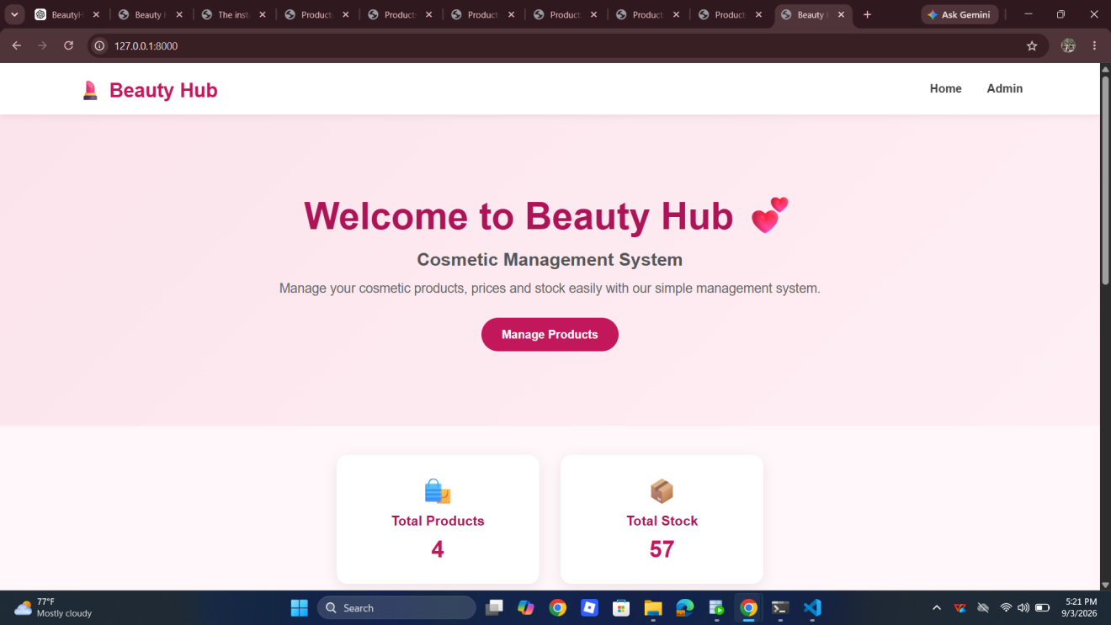

Screenshot 2 — Product List
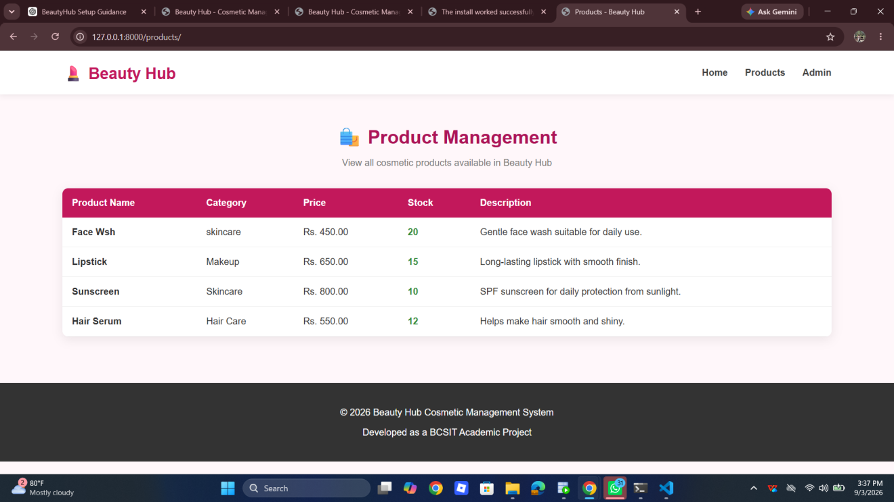

Screenshot 3 — Add Product
Show the Add Product form.

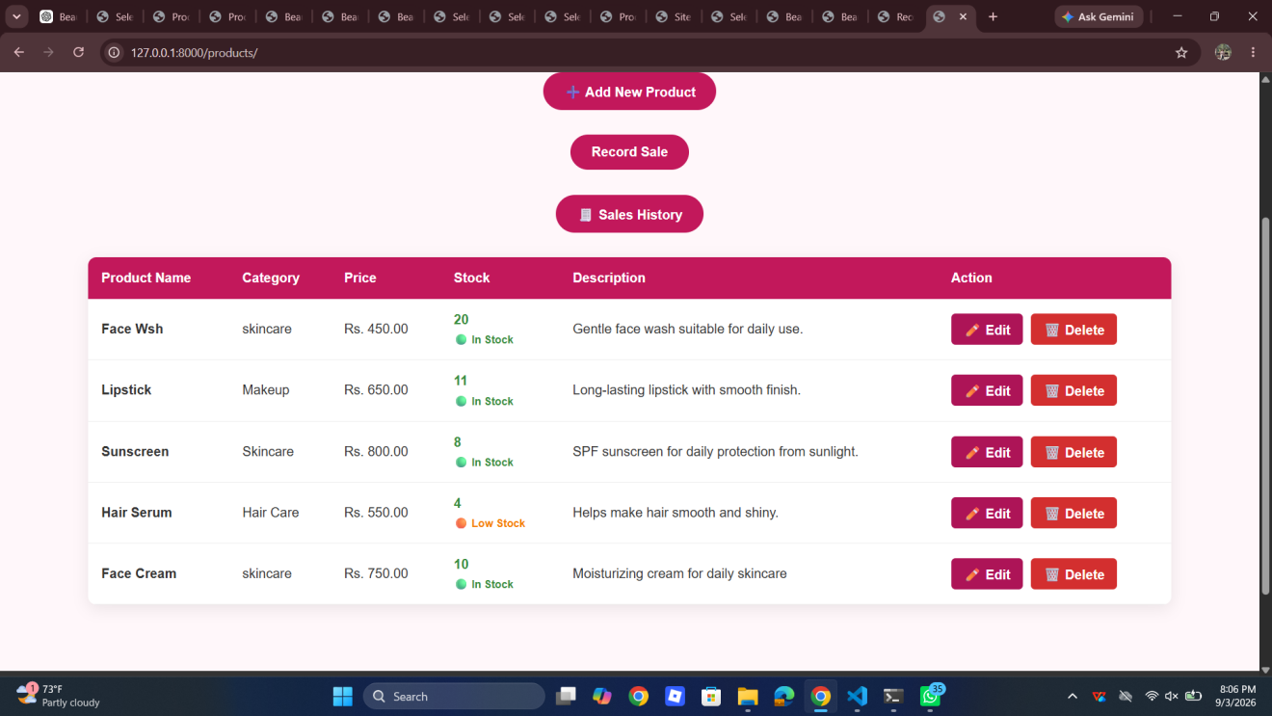

Screenshot 4 — Edit Product
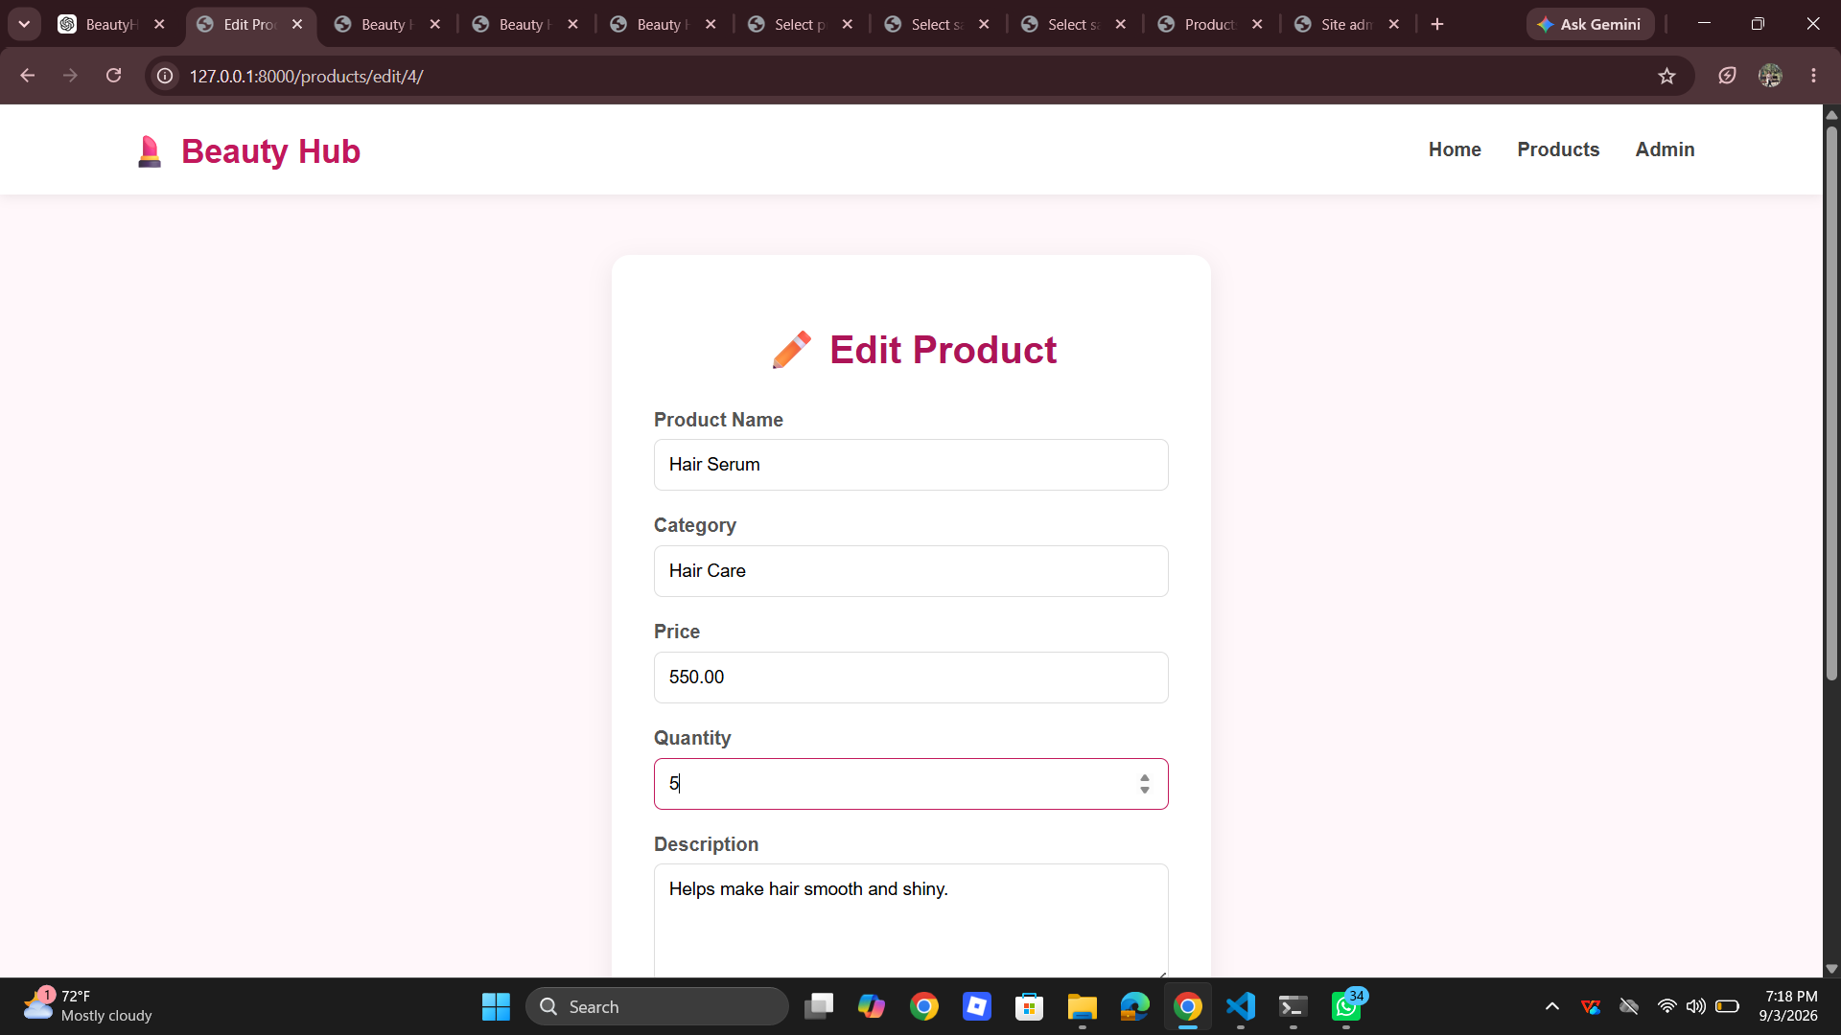

Screenshot 5 — Search and Category Filter
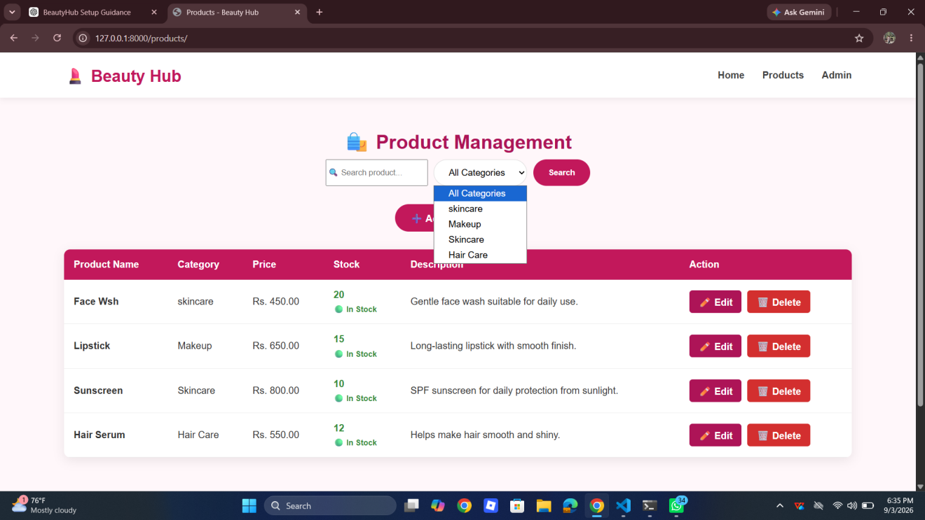

Screenshot 6 — Customer Management
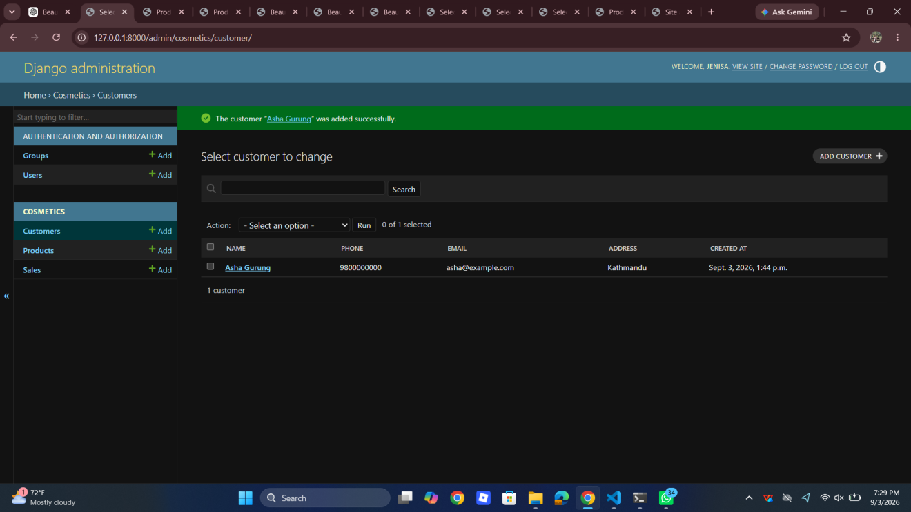

Screenshot 7 — Record Sale

Screenshot 8 — Sales Validation

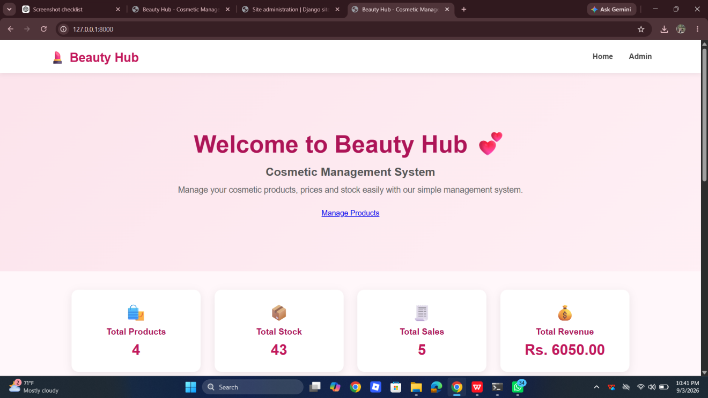

Screenshot 9 — Sales History
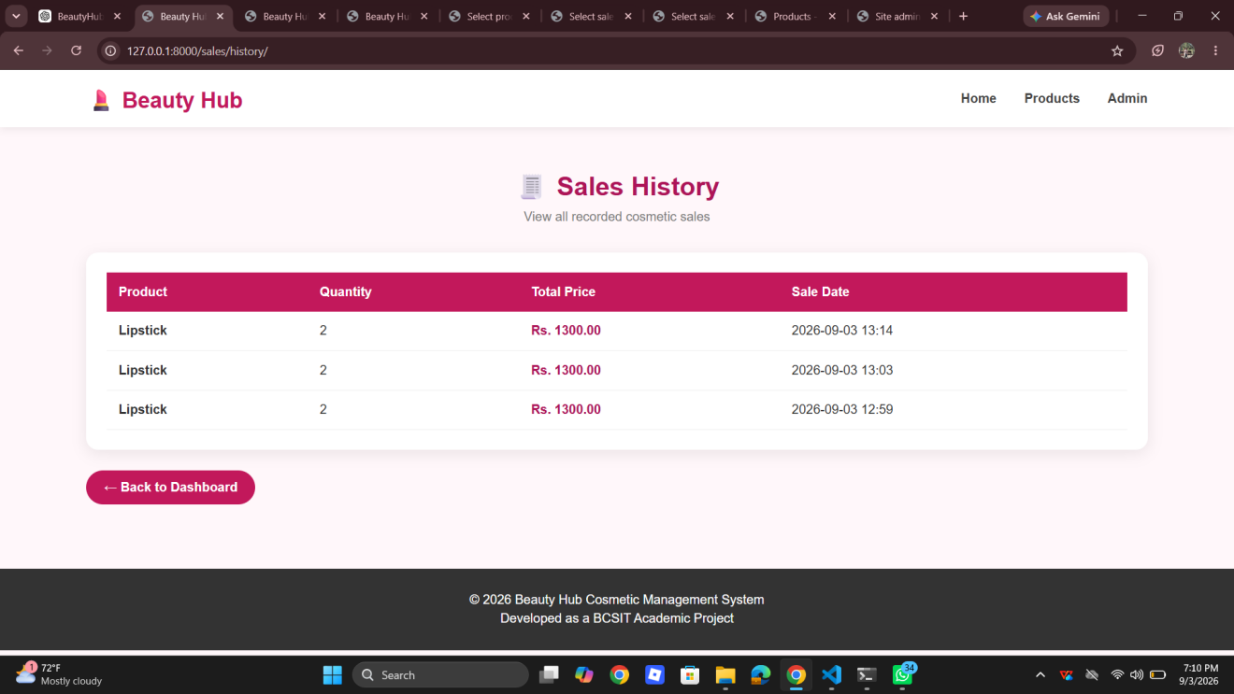

Screenshot 10 — Django Admin

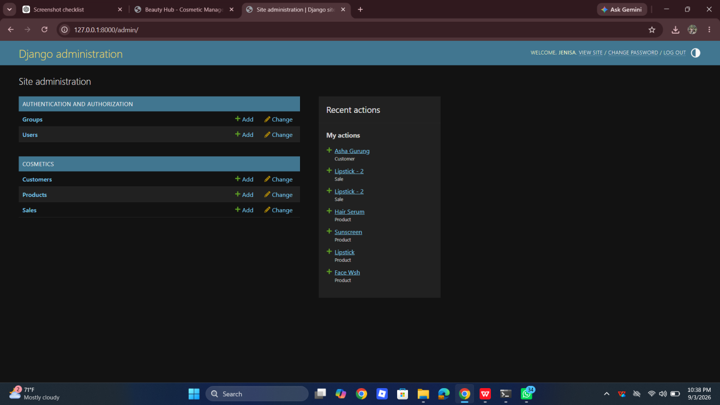

Screenshot 11 — Oracle Connection
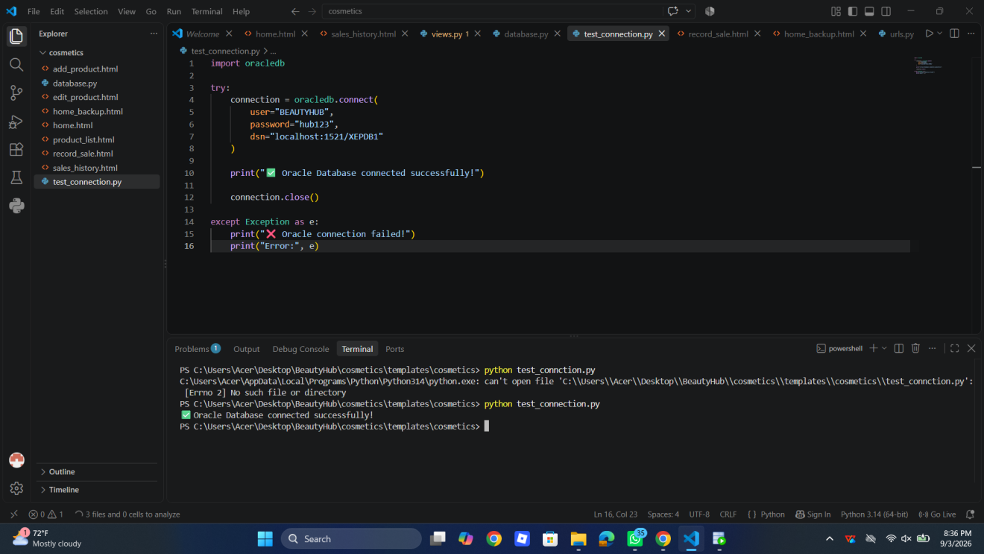

APPENDIX B: SAMPLE PROJECT DATA
Product | Category | Price | Stock
Face Wsh | Skincare | Rs. 450 | 20
Lipstick | Makeup | Rs. 650 | 11
Sunscreen | Skincare | Rs. 800 | 8
Hair Serum | Hair Care | Rs. 550 | 4
Sample customer:
Name | Phone | Email | Address
Asha Gurung | 9800000000 | asha@example.com | Kathmandu

APPENDIX C: SAMPLE SALE
Example:
Product: Hair Serum
Customer: Asha Gurung
Quantity: 1
Price: Rs. 550
Total: Rs. 550
The system automatically decreases the Hair Serum stock after the sale.

PROJECT SUMMARY
Project Title: Beauty Hub Cosmetic Management System
Application Type: Web-based Enterprise Application
Programming Language: Python
Framework: Django
Frontend: HTML, CSS
Database: Oracle Database
Database Driver: Python oracledb
Main Modules:
- Product Management
- Customer Management
- Inventory Management
- Sales Management
- Sales History
- Dashboard
- Administration
- Oracle Database Connectivity
Project Objective:
To develop an efficient computerized system for managing cosmetic products, customers, inventory and sales.

